Curriculum Overview 2022-2023
Year 6
 | Autumn Term | Spring Term | Summer Term
Enquiry Question | How Sustainable is Our Planet? | Does Conflict Lead to Change? | What Does Success Look Like?
Key Curriculum Area | Humanities  Health & Wellbeing | Science and Technology  Literacy, Language and Communication | Expressive Arts  Mathematics & Numeracy
Examples of experiences and activities covered | Live lessons with scientists involved with Antarctic and underwater exploration,  Science fair/exhibition,  Building sustainable future homes | Cardiff museum  Debates & discussion  Children’s Rights  Podcasting  News reports | Researching  Entrepreneurism  Dragon’s Den style event  Leavers’ show  Organise their prom  Textiles / costume design
 | 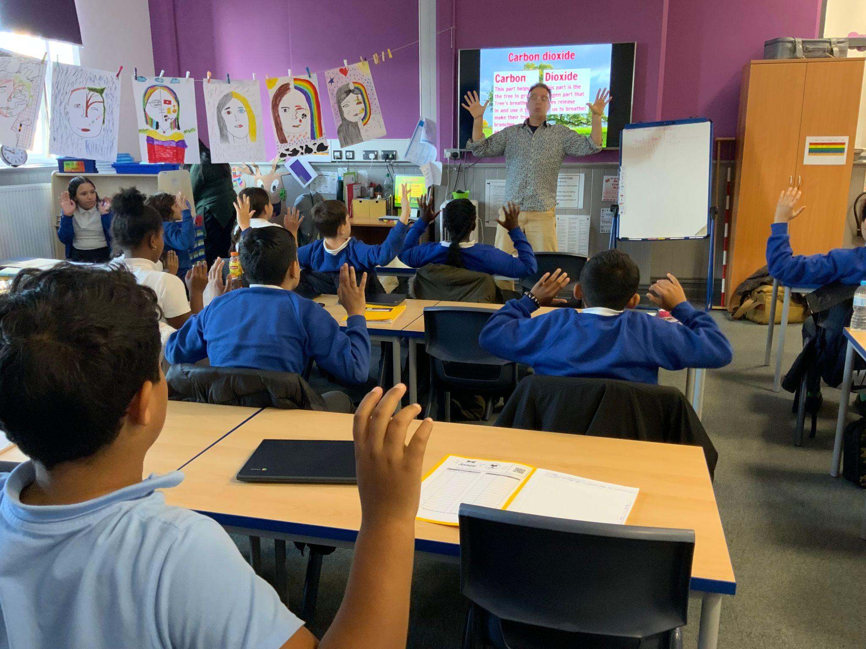 | 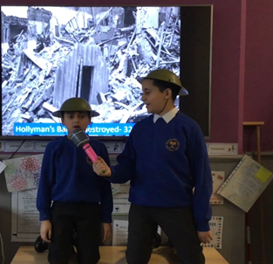 | 

