Curriculum Overview 2022-2023
Year 4
 | Autumn Term | Spring Term | Summer Term
Enquiry Question | Why are we here? | Which is more powerful, Science or Magic? | What would you sacrifice for success?
Key Curriculum Area | Health and Wellbeing  Language, Literacy and Communication  Humanities | Science and Technology Language, Literacy and Communication  Maths and Numeracy | Health and Wellbeing  Science and Technology  Creative arts
Examples of experiences and activities covered | Mindfulness sessions in class  Visit to St Fagans Museum  Create Roman shields  Creation of scrapbook | Magic show  Trip to Techniquest  Science experiments | Create sports day games  Investigate healthy eating  Create class songs  Create posters

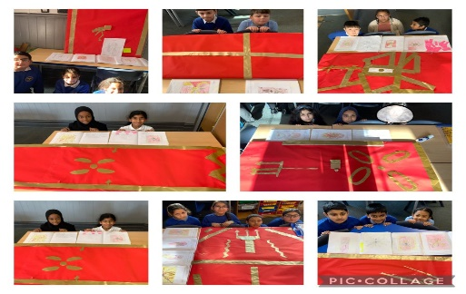 | 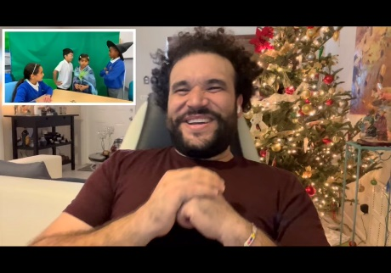 | 

