Curriculum Overview 2022-2023
Year 3
 | Autumn Term | Spring Term | Summer Term
Enquiry Question | How does the past shape the future? | Is nature cruel or kind? | What makes our world beautiful?
Key Curriculum Area | Humanities,  Language, Literacy and Communication | Science & Technology  Language, Literacy and Communication | Creative Arts  Language, Literacy and Communication
Examples of experiences and activities covered | Visit to St Fagans Museum  Class Time Lines | Weather forecasts, iMovie documentary. | Class art gallery  Study of local artists/ visits from local artists.

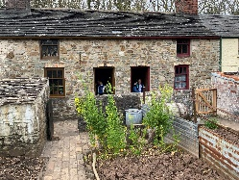  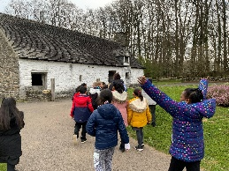 | 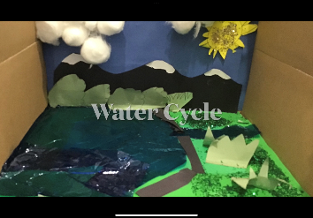 | 

