Curriculum Overview 2024-2025
Year 2
 | Autumn Term | Spring Term | Summer Term
Enquiry Question | What does it mean to be a Cardiff citizen? | Can the oceans be ruled? | What does wellbeing mean to us?
Key Curriculum Area | Humanities  Science and Technology  Mathematics and Numeracy. | Humanities  Expressive arts  Language, Literacy and Communication  Science and Technology. | Health and Wellbeing  Language, Literacy and Communication  Expressive arts.
Examples of experiences and activities covered | Trip to a local/ historical attraction.  Welsh history, looking at local maps.  Diversity and Community. | Exploring environmental matters.  Ocean animal lifecycles.  Identifying ocean habitats.  Newspaper reports. | Mindfulness sessions and yoga in class,  Healthy eating and hygiene.  Music and dance.  Resilience through story.

Photo from autumn term here  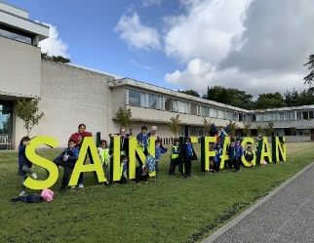  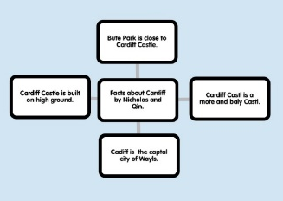 | Photo from Spring term here  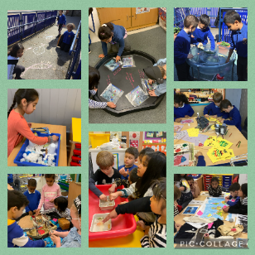  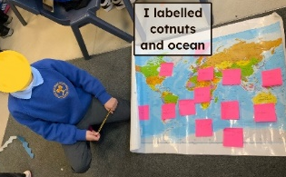 | Photo from Summer term here  

